Kubernet PVC

Reference URL :- <https://www.learnitguide.net/2020/03/kubernetes-persistent-volumes-and-claims.html>

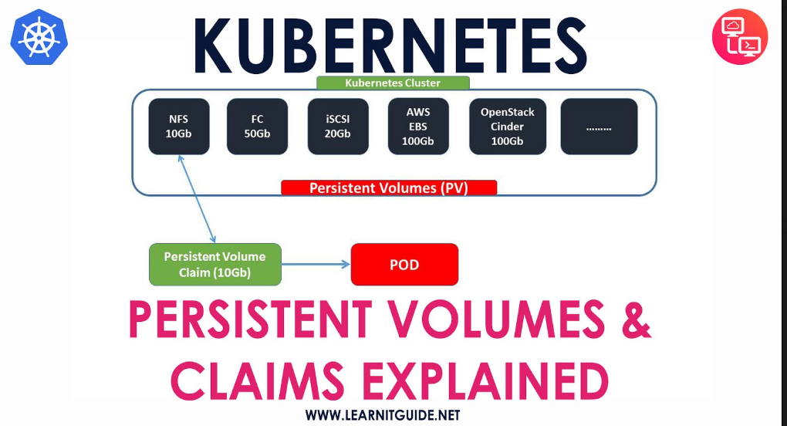

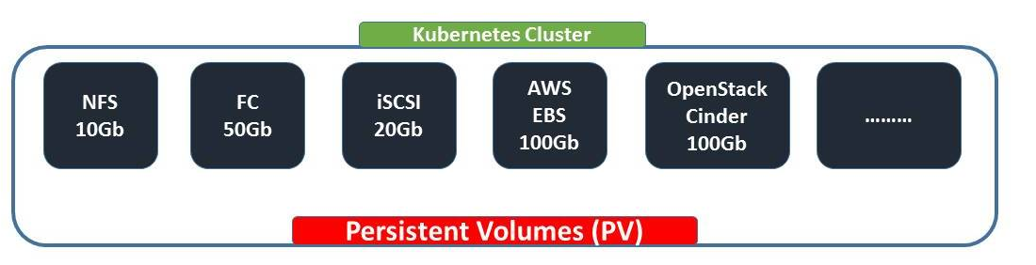

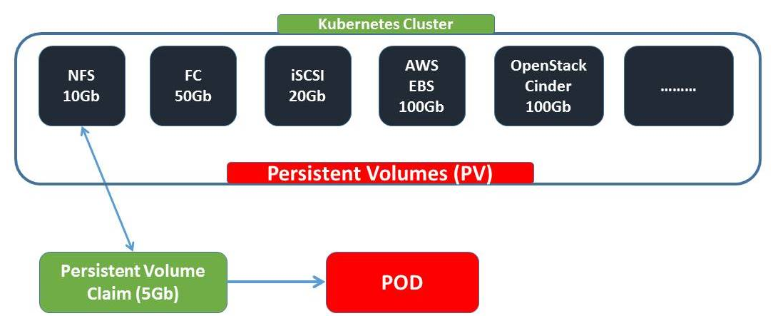

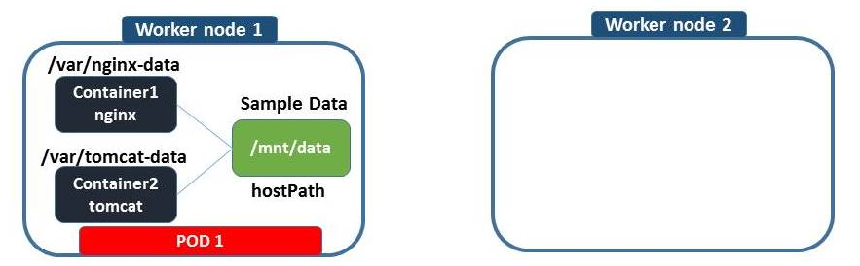

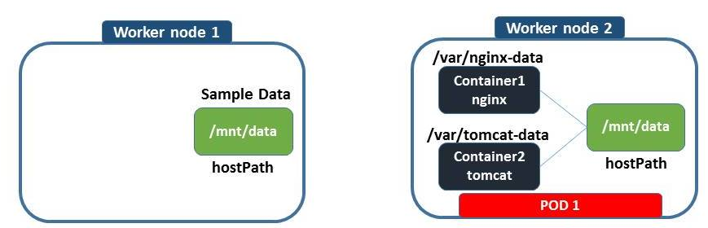

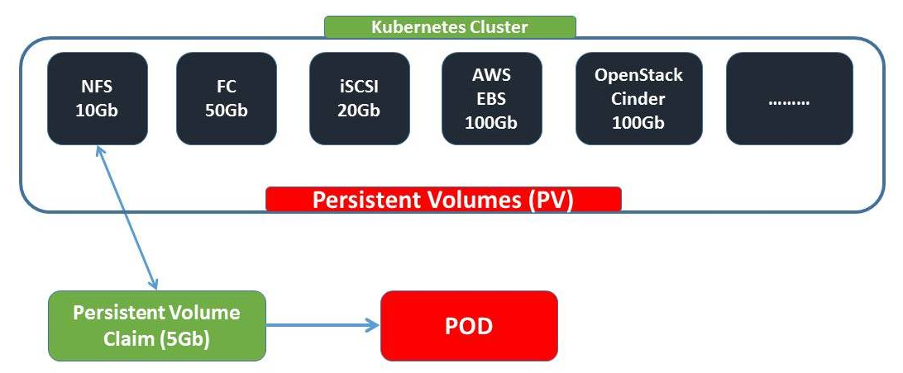

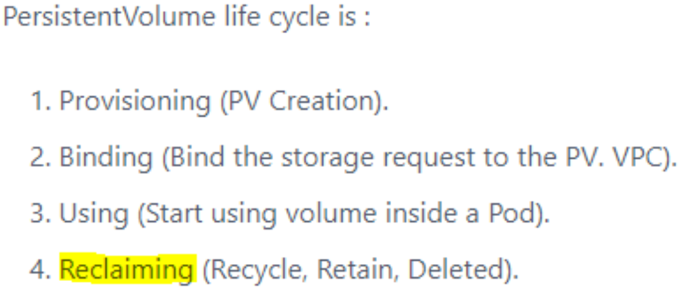

**Claim Policies**

We also reference claim policies earlier. A Persistent Volume can have several different claim policies associated with it including:

**Retain** – When the claim is deleted, the volume remains.

**Recycl**e – When the claim is deleted the volume remains but in a state where the data can be manually recovered.

**Delete** – The persistent volume is deleted when the claim is deleted.Persistent Volumes

Persistent Volumes are simply a piece of storage in your cluster. Similar to how you have a disk resource in a server, a persistent volume provides storage resources for objects in the cluster. At the most simple terms you can think of a PV as a disk drive. It should be noted that this storage resource exists independently from any pods that may consume it. Meaning, that if the pod dies, the storage should remain intact assuming the claim policies are correct. Persistent Volumes are provisioned in two ways, Statically or Dynamically.

Static Volumes – A static PV simply means that some k8s administrator provisioned a persistent volume in the cluster and it’s ready to be consumed by other resources.

Dynamic Volumes – In some circumstances a pod could require a persistent volume that doesn’t exist. In those cases it is possible to have k8s provision the volume as needed if storage classes were configured to demonstrate where the dynamic PVs should be built. This post will focus on static volumes for now.

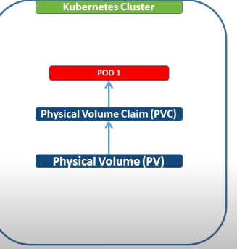

1. To create PV

2. To create PVC

3. To create pod

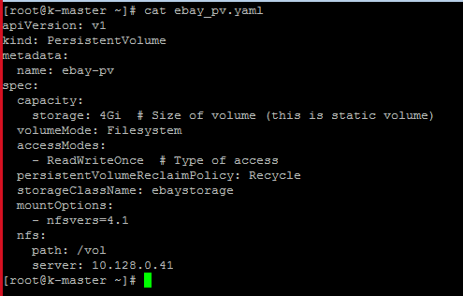

[root@k-master ~]# kubectl get pv

No resources found in default namespace.

[root@k-master ~]# kubectl create -f ebay_pv.yaml --dry-run

W0627 07:50:11.531432 20729 helpers.go:535] --dry-run is deprecated and can be replaced with --dry-run=client.

persistentvolume/ebay-pv created (dry run)

[root@k-master ~]#

[root@k-master ~]# kubectl create -f ebay_pv.yaml

persistentvolume/ebay-pv created

[root@k-master ~]# kubectl get pv

NAME CAPACITY ACCESS MODES RECLAIM POLICY STATUS CLAIM STORAGECLASS REASON AGE

ebay-pv 4Gi RWO Recycle Available ebaystorage 4s

[root@k-master ~]#

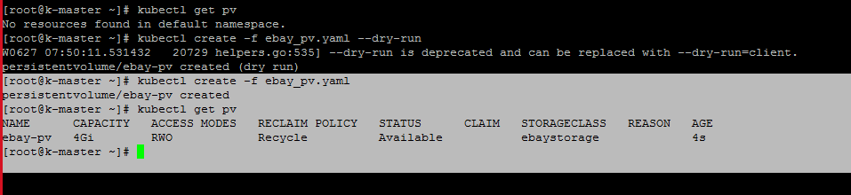

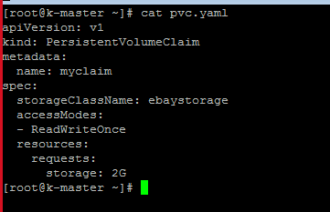

[root@k-master ~]# kubectl create -f pvc.yaml --dry-run

W0627 07:53:55.615430 21421 helpers.go:535] --dry-run is deprecated and can be replaced with --dry-run=client.

persistentvolumeclaim/myclaim created (dry run)

[root@k-master ~]# kubectl get pvc

No resources found in default namespace.

[root@k-master ~]# kubectl create -f pvc.yaml

persistentvolumeclaim/myclaim created

[root@k-master ~]# kubectl get pvc

NAME STATUS VOLUME CAPACITY ACCESS MODES STORAGECLASS AGE

myclaim Bound ebay-pv 4Gi RWO ebaystorage 2s

[root@k-master ~]#

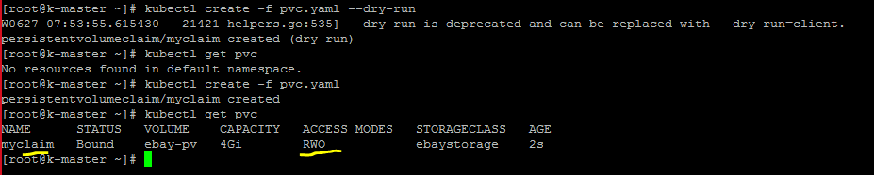

[root@k-master ~]# vim httpd-basic-deployment.yaml

[root@k-master ~]# kubectl create -f httpd-basic-deployment.yaml --dry-run

W0627 07:57:20.392341 22036 helpers.go:535] --dry-run is deprecated and can be replaced with --dry-run=client.

deployment.apps/ebay-app created (dry run)

[root@k-master ~]# cat httpd-basic-deployment.yaml

kind: Deployment

apiVersion: apps/v1

metadata:

name: ebay-app

spec:

selector:

matchLabels:

environment: dev

app: ebay

replicas: 1

template:

metadata:

labels:

environment: dev

app: ebay

spec:

volumes:

- name: myvolume

persistentVolumeClaim:

claimName: myclaim

containers:

- name: container1-nginx

image: nginx

volumeMounts:

- name: myvolume

mountPath: "/tmp/persistent"

- name: container2-tomcat

image: tomcat

[root@k-master ~]# kubectl get pods

No resources found in default namespace.

[root@k-master ~]# kubectl create -f httpd-basic-deployment.yaml

deployment.apps/ebay-app created

[root@k-master ~]# kubectl get pods

NAME READY STATUS RESTARTS AGE

ebay-app-6c8d8747f5-77cqb 2/2 Running 0 4s

[root@k-master ~]#

[root@k-master ~]# kubectl get pods

No resources found in default namespace.

[root@k-master ~]# kubectl create -f httpd-basic-deployment.yaml

deployment.apps/ebay-app created

[root@k-master ~]# kubectl get pods

NAME READY STATUS RESTARTS AGE

ebay-app-6c8d8747f5-77cqb 2/2 Running 0 4s

[root@k-master ~]# kubectl describe pod ebay-app-6c8d8747f5-77cqb

